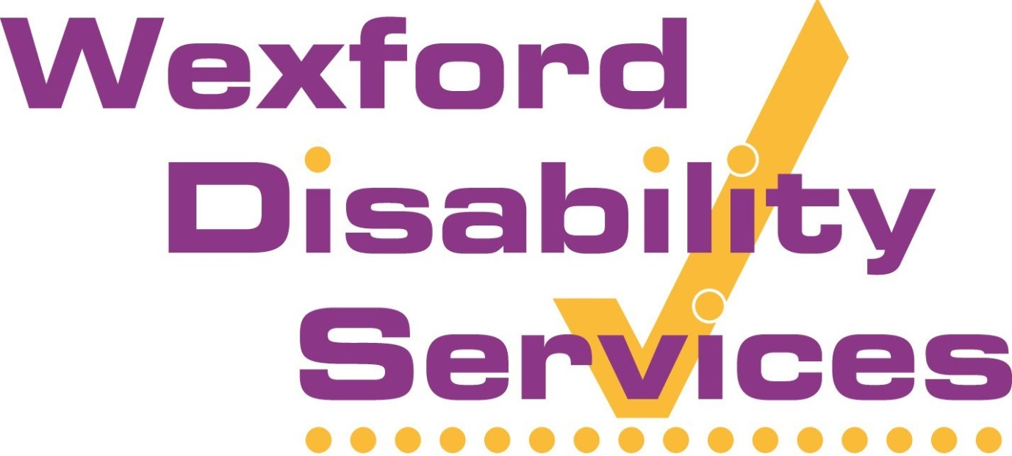

Annual General Meeting
2017

Chairperson’s Annual Address 2017
As the Chairperson of the Board of Directors of Wexford Disability Services, I would like to thank you for attending this year’s Annual General Meeting. I would particularly like to welcome our new Board members – Tony Hynes, Paddy Foley.
I also take this opportunity to report briefly on the charity’s progress over the past year. We have had another good year. During the course of 2017, our organisation delivered 33,404 hours of quality service to 67 service-users. This is an increase of 1,009 hours from 2016. The fact that the HSE continues to increase the hours of services which we are contracted to provide, is testament to our strong reputation in the sector.
This, in turn, is a reflection of the high quality of service delivered by our staff on the ground. Our 38 Personal Assistants deliver services ranging from high dependency to general home-help. It is thanks to their hard work and dedication that WDS has such a good reputation, so I take this opportunity to thank them all sincerely for their efforts over the past year.
It must be remembered that the purpose of our charity continues to be the provision of a Quality, Not-for-Profit, Person-Centred Personal Assistance service that is delivered by dedicated staff. The provision of a quality service continues to be the core driver for our organisation. We have developed a standardised methodology which enables us to adopt individual care-plans for each of our Clients. Our system means that we deliver a respectful person-centred service which is effective and ensures the best outcomes for our clients.
Bearing this in mind, I must thank Declan, our Manager, for not only maintaining the high quality of service delivery by our organisation, but for ensuring continuous improvements in terms of quality and volume of services.
Debbie, our Financial Administrator, receives our thanks for her ever-efficient work in relation to all financial matters.
I also wish to acknowledge Ms. Ann Gallagher’s work on our Corporate Governance Audit report. We as a Board look forward to the implementation of its recommendations and to signing up to the Code of Governance for the Community and Voluntary Sector.
Additionally, I would like to thank our auditor, Mr. Sean Hennessy, for his continued professional approach when dealing with the financial auditing of the organisation.
Sincere thanks are also due to my fellow Board Directors for their attendance at meetings throughout 2017 and their additional participation in the Corporate Governance Audit. Each Director gives of their time freely, and their advice and assistance is much appreciated.
Finally, I am confident that WDS is in a sound financial position and that we will continue to provide a quality service for our clients into the future.
David Hynes, Chairperson.
28th March, 2018

Wexford Disability Development CIL (CLG)
trading as Wexford Disability Services

Report of the Board of Directors for the year ended 31st December 2017

The Board of Directors presents its report and audited financial statement for the year ended 31st December 2017.
Reference and Administration Information
Charity Name: Wexford Disability Development (CIL) CLG trading as Wexford Disability Services
Charity Regulator number: 20040918
Revenue Registered number: CHY13277
Registered Company number: 340183
Employer number: 9546409K
Registered Office: Westlands Community Centre, St. John’s Drive, Wexford
Board of Directors
Cllr. David Hynes: Chairperson
Mr. Jim Dempsey: Company Secretary
Mrs. Anna Fenlon
Ms. Regina Maguire
Ms. Caroline Dempsey
Mr. Anthony Hynes
Management:
Declan Denny: CEO
Debbie Kendall: Financial Administrator

Auditor – Mr Sean Hennessy Bank – Bank of Ireland
Our Aims and Objectives
Our charity’s purpose as set out in the objects contained in the Company’s Constitution:
- To provide Personal Assistants to people with disabilities, noting that these assistants will work under the direction of the person with such a disability as well as the Company in accordance with the agreed Care Plan;
- To promote and improve the availability of work, education and social activities for People with Disabilities by promoting an awareness of the problems and difficulties faced by people with disabilities, to provide schooling, employment, residential and social facilities, workshops and generally to provide a Programme to help disabled persons living at home and in the community;
- To promote, encourage and support independence and equality for People with Disabilities in their personal and working lives, accommodation facilities, and in all areas of the community and the built environment;
- To liaise with other community-based groups, schemes, bodies, projects, sponsorship and other involvement such as supervising, administering and/or implementing programs, projects, enterprises, jointly or otherwise, for the provision, enhancement and improvement of services for those with disabilities.
The aim of our charity is to provide a quality person-centered service to enable our service-users to live at home independently.
Ensuring our Work delivers our Aims
We review our aims, objectives and activities every year. The review looks at what we have achieved and the outcomes of our work in the previous 12 months. The review looks at the success of each key activity and the benefits they have brought to our servies-users. The reivew also helps to guide and ensure that our aims, objectives and activities remain focused on our stated purposes.
This year, we, as a Board of Directors, commisioned a Corporate Governance Audit by Ms. Ann Gallagher to ensure that the organisation is in compliance with all of its legal and regulatory requirements. A summary of the Audit Report will be published on our website in due course.
The focus of our work
Our main objectives for 2017 continued to be the provision of a quality,person-centered service. The strategies used to meet these objectives included:
- The continued use of standardised Care-Plans tailored to clients’ individual needs
- A person-centered approcah that is respectfful and responsive to service-users needs
- Effective services delivered to ensure the best outcome for the service-user
- Safe service-delivery through targeted recruitment of qualified healthcare assistants and/or persons with demonstrated long service in the sector.
- Adherance to, and implementation of, sound risk management procedures.
- Targeted specilist training when required.
Challenges to future delivery of our work
There are three main challenges facing our organisation in the near future.
- Difficulty in recruiting suitably qualified persons to carry out our work
- Increased oversight from the Charity Regulator
- Legislative changes to existing employment law
1. Recruitment of new staff continues to be difficult. However, the CEO has utilised the contacts of existing staff to source a limited number of new employees. This development has proven to be fruitful but a full recruitment campaign is required in 2018. As stated in last years Report, this situation is not unique to WDS as other service-providers are experiencing similar difficulties.
2. The expected increase in the level of reporting to the Charities Regulator has yet to transpire. However, we as a Board believe that when the recommendations of the Coporate Governence Audit Report are carried out, our organisation will be in a postion to show that it complies with all regulatory requirements.
3. Proposed legislative changes to employment law to outlaw zero-hour contracts may lead to changes in contracts of employment being required. Once again, we as a Board of Directors feel that we will be in a position to deal with any changes in the law in this area.
How our Activities deliver Public Benefit
Our main activities and the beneficiaries of our serrvices are outlined below. All of our activities are focused on the provision of Independent Living through the provision of a quality service.
Who used and benifited from our services?
- 61 Adult service-users
29,865 hours delivered
- 6 Child service-users
3,539 hours delivered

The main areas of activity and assistance includes basic home-help, high-dependency care, workplace assistance, pre-school education assistance, personal-care and social activities.
Our supports enables many people with disabilities to live and enjoy more independent lives than they could otherwise achieve.
However, the impact of our services goes beyond those that we assist directly. Our service reduces and relieves some of the stress suffered by the close and extended families of our service-users.
Our services gives respite, personal time and space, etc. for the other carers involved.
In addition, our service provides value for money to the Irish taxpayer through the delivery of an effective and quality driven service.

